**Use Case: See Which Stores carry which products**

**Frame #1**

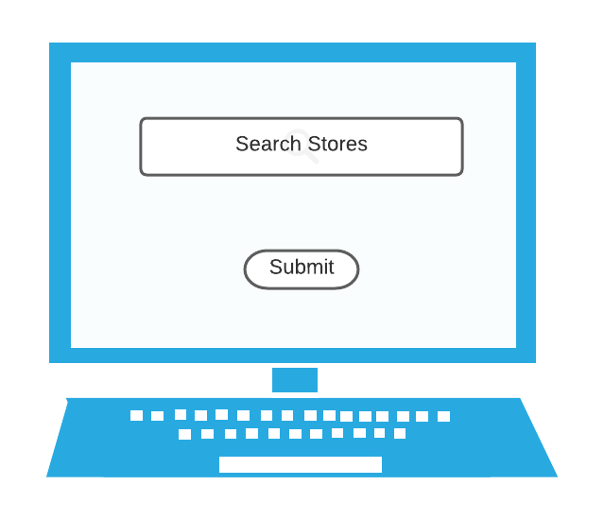

**Frame #2**

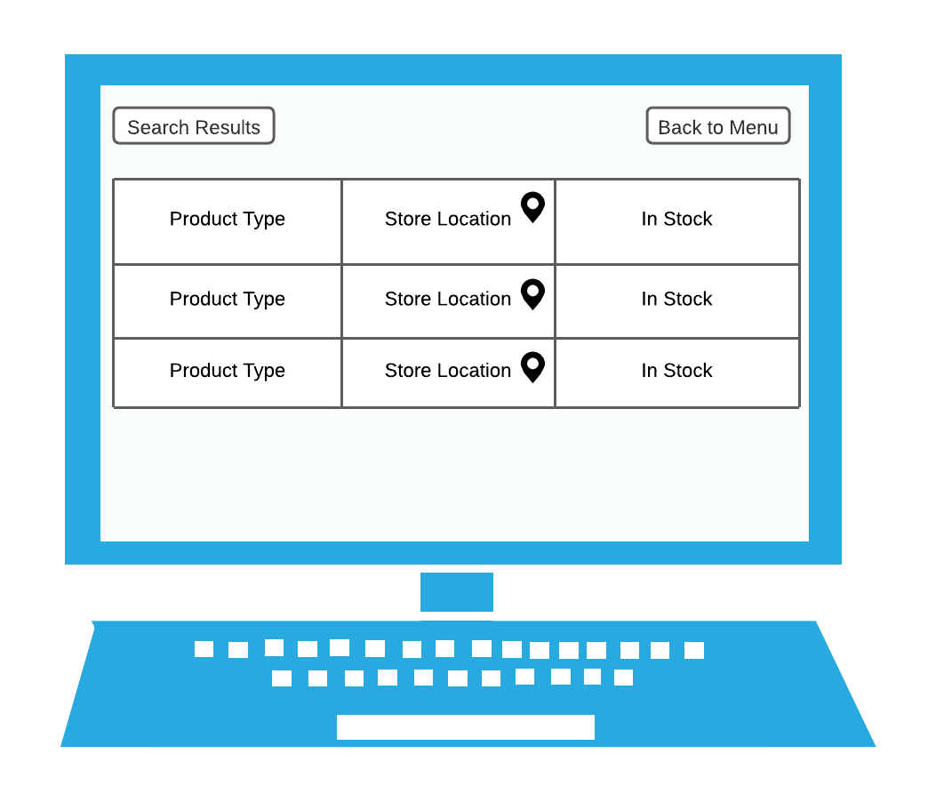

**Use Case: Add Fish and Supplies in Inventory**

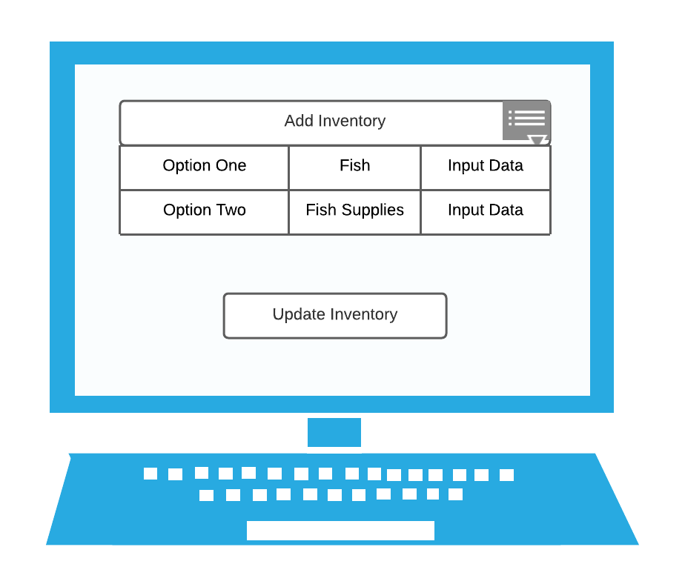

**Use Case: Search For Product**

**Frame #1**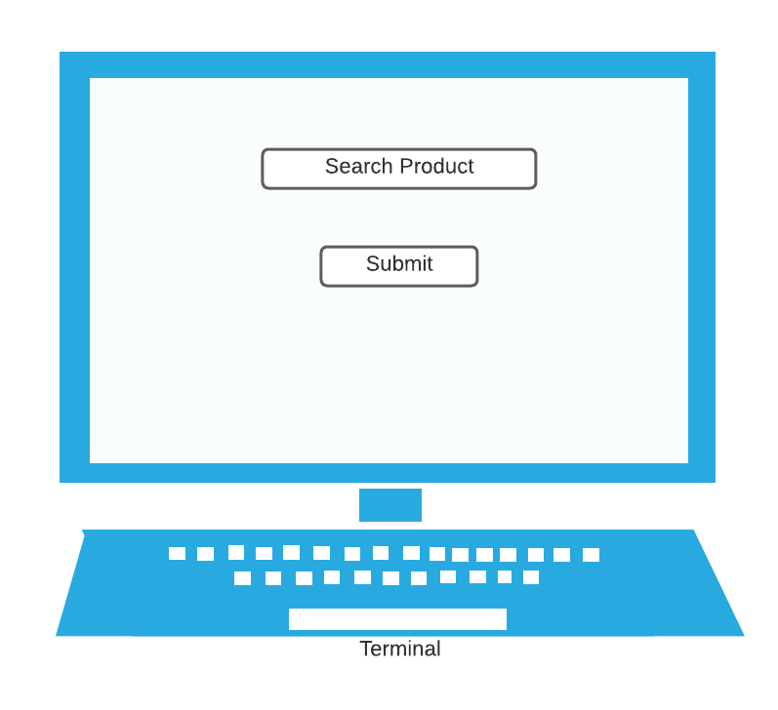

**Frame #2**

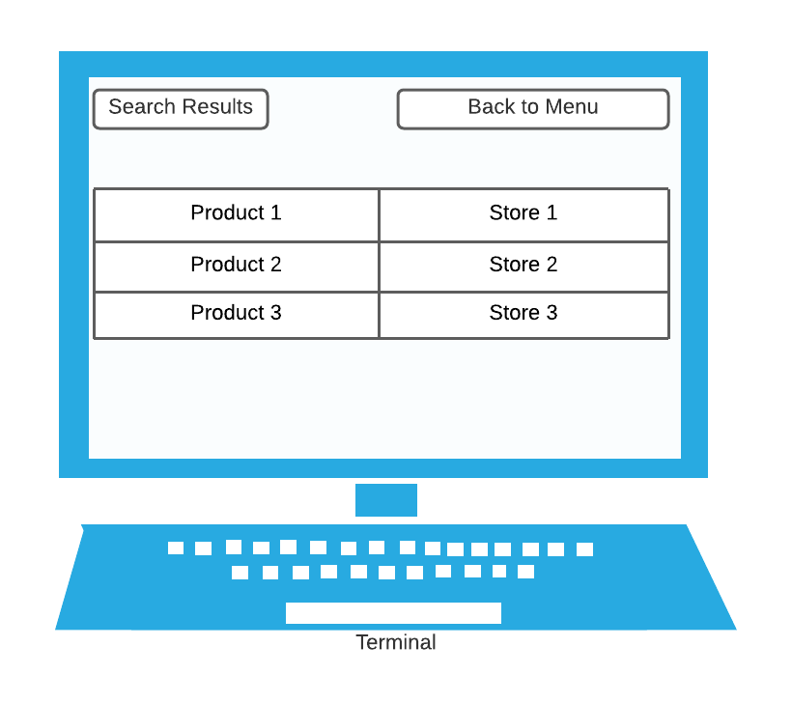

**Use Case: Buying a Product**

**Frame #1 Frame #2**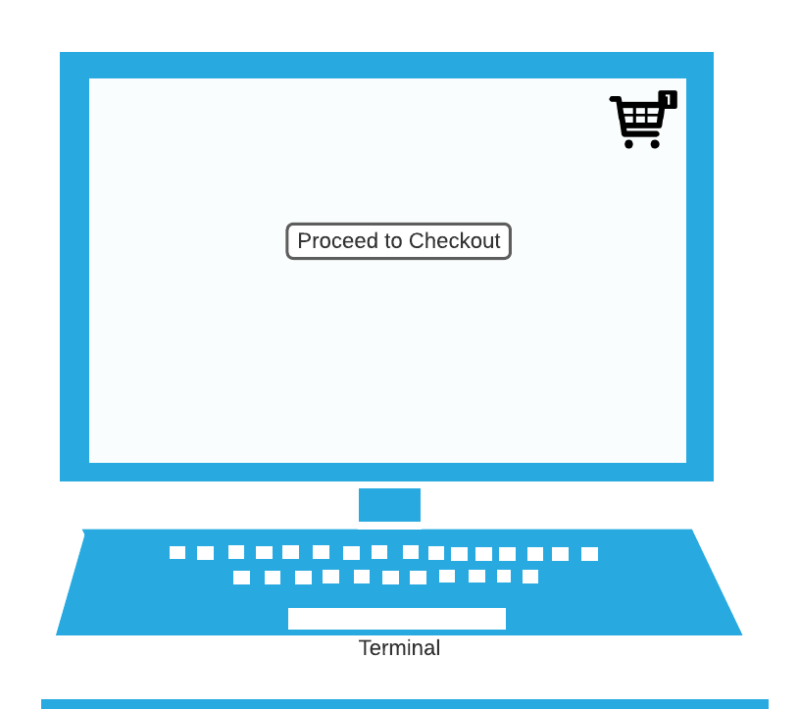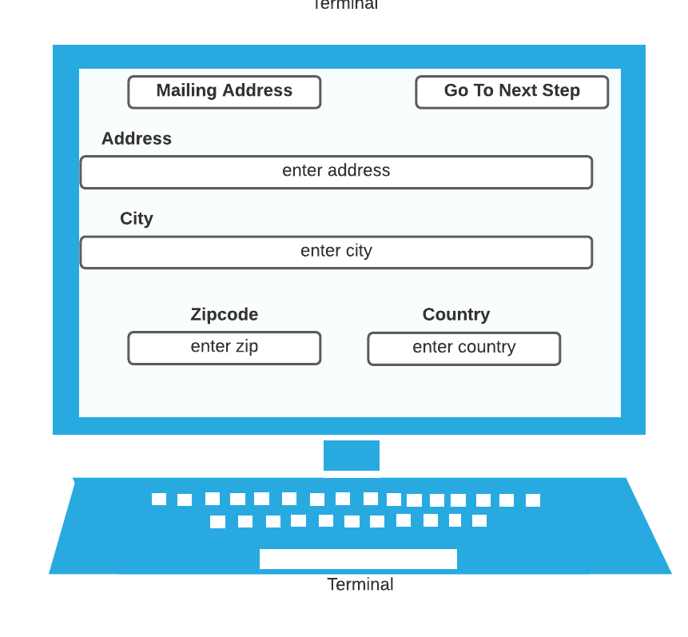

**Frame #3**

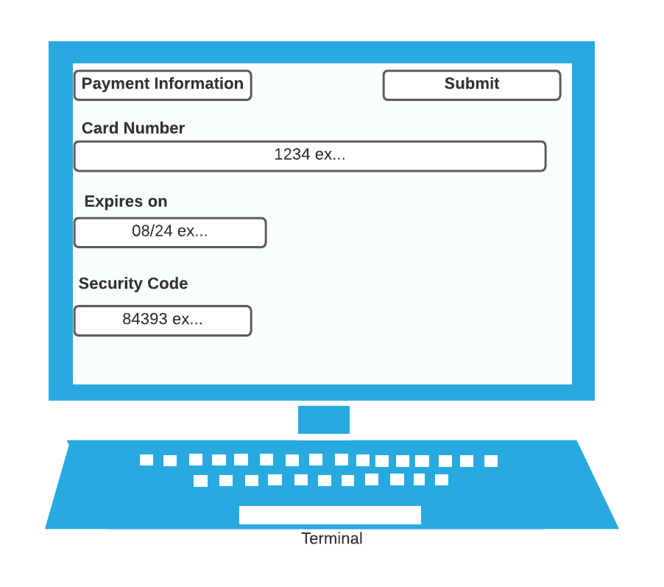

**Use Case: Add product to shopping cart**

